**MA111 ASSIGNMENT 1**

**Group Information**

|  |  |
| --- | --- |
| **Name** | **Student Id** |
| Joash Mario | S11213560 |
| Saimoni Coalala | S11213074 |
| Adrian Alamu | S11209521 |

**Question1**

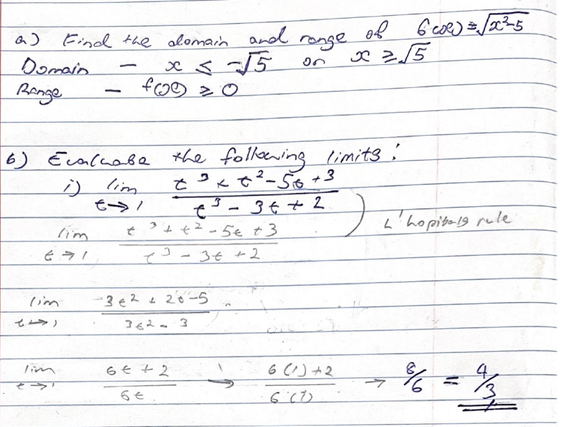

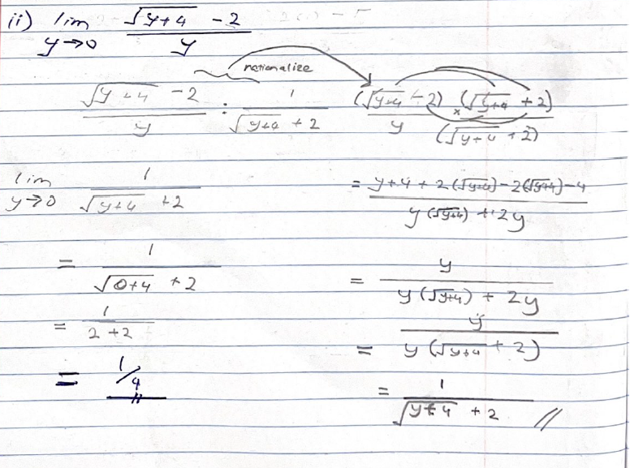

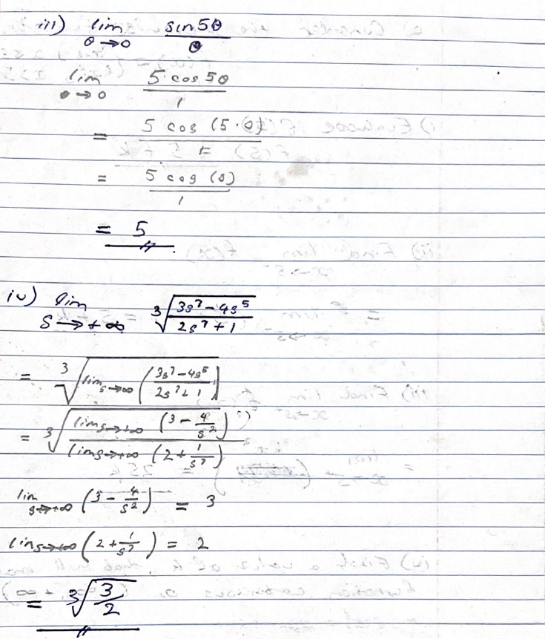

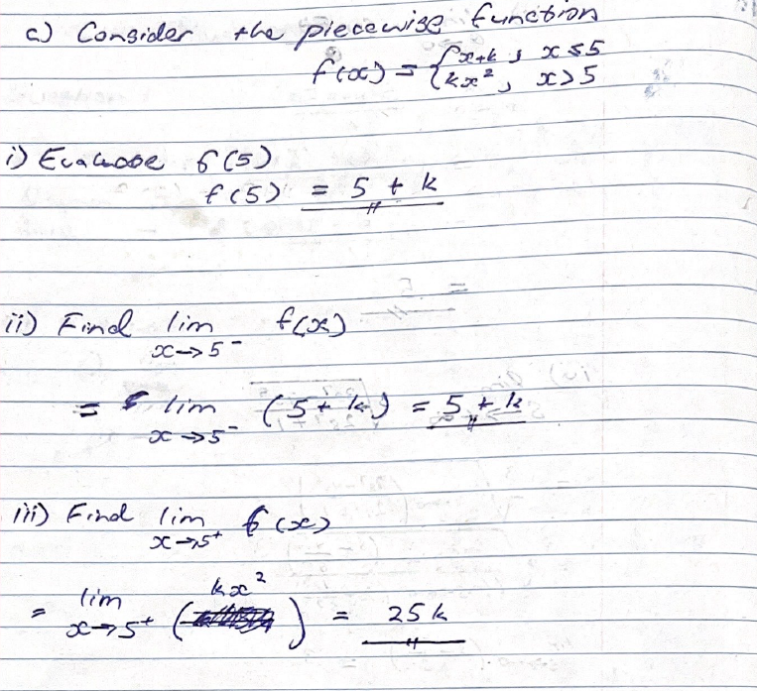

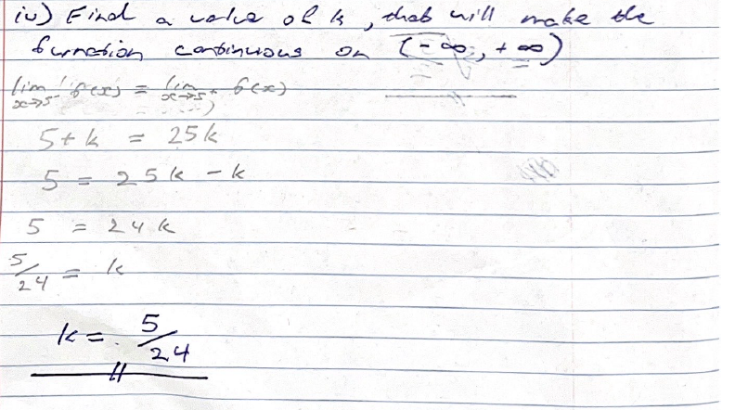

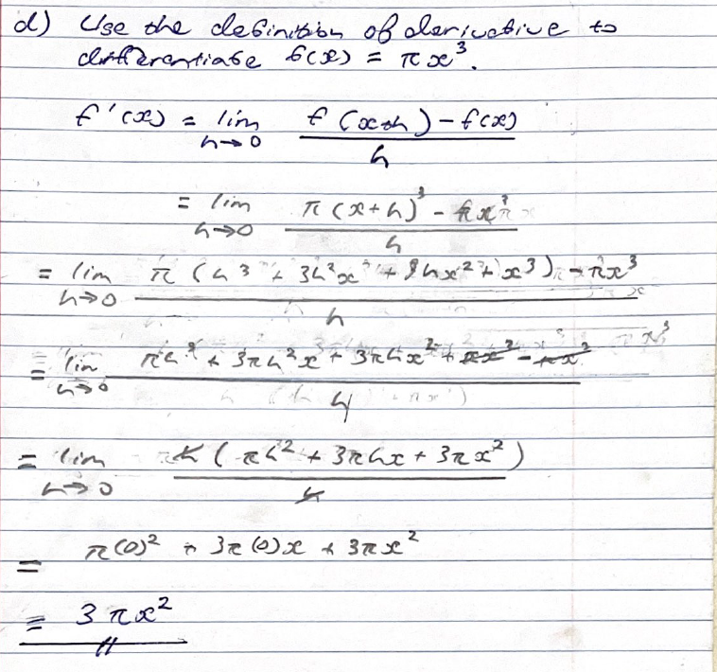

**Question2**

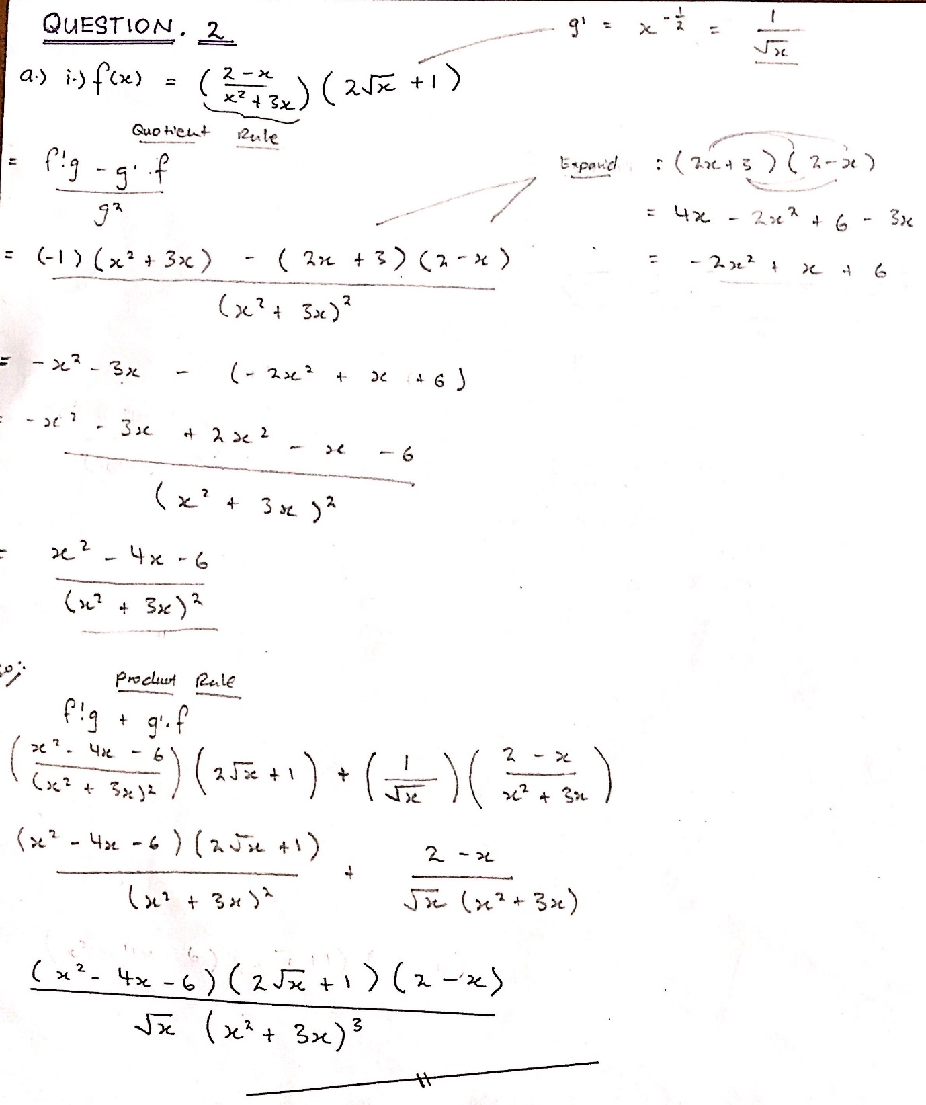

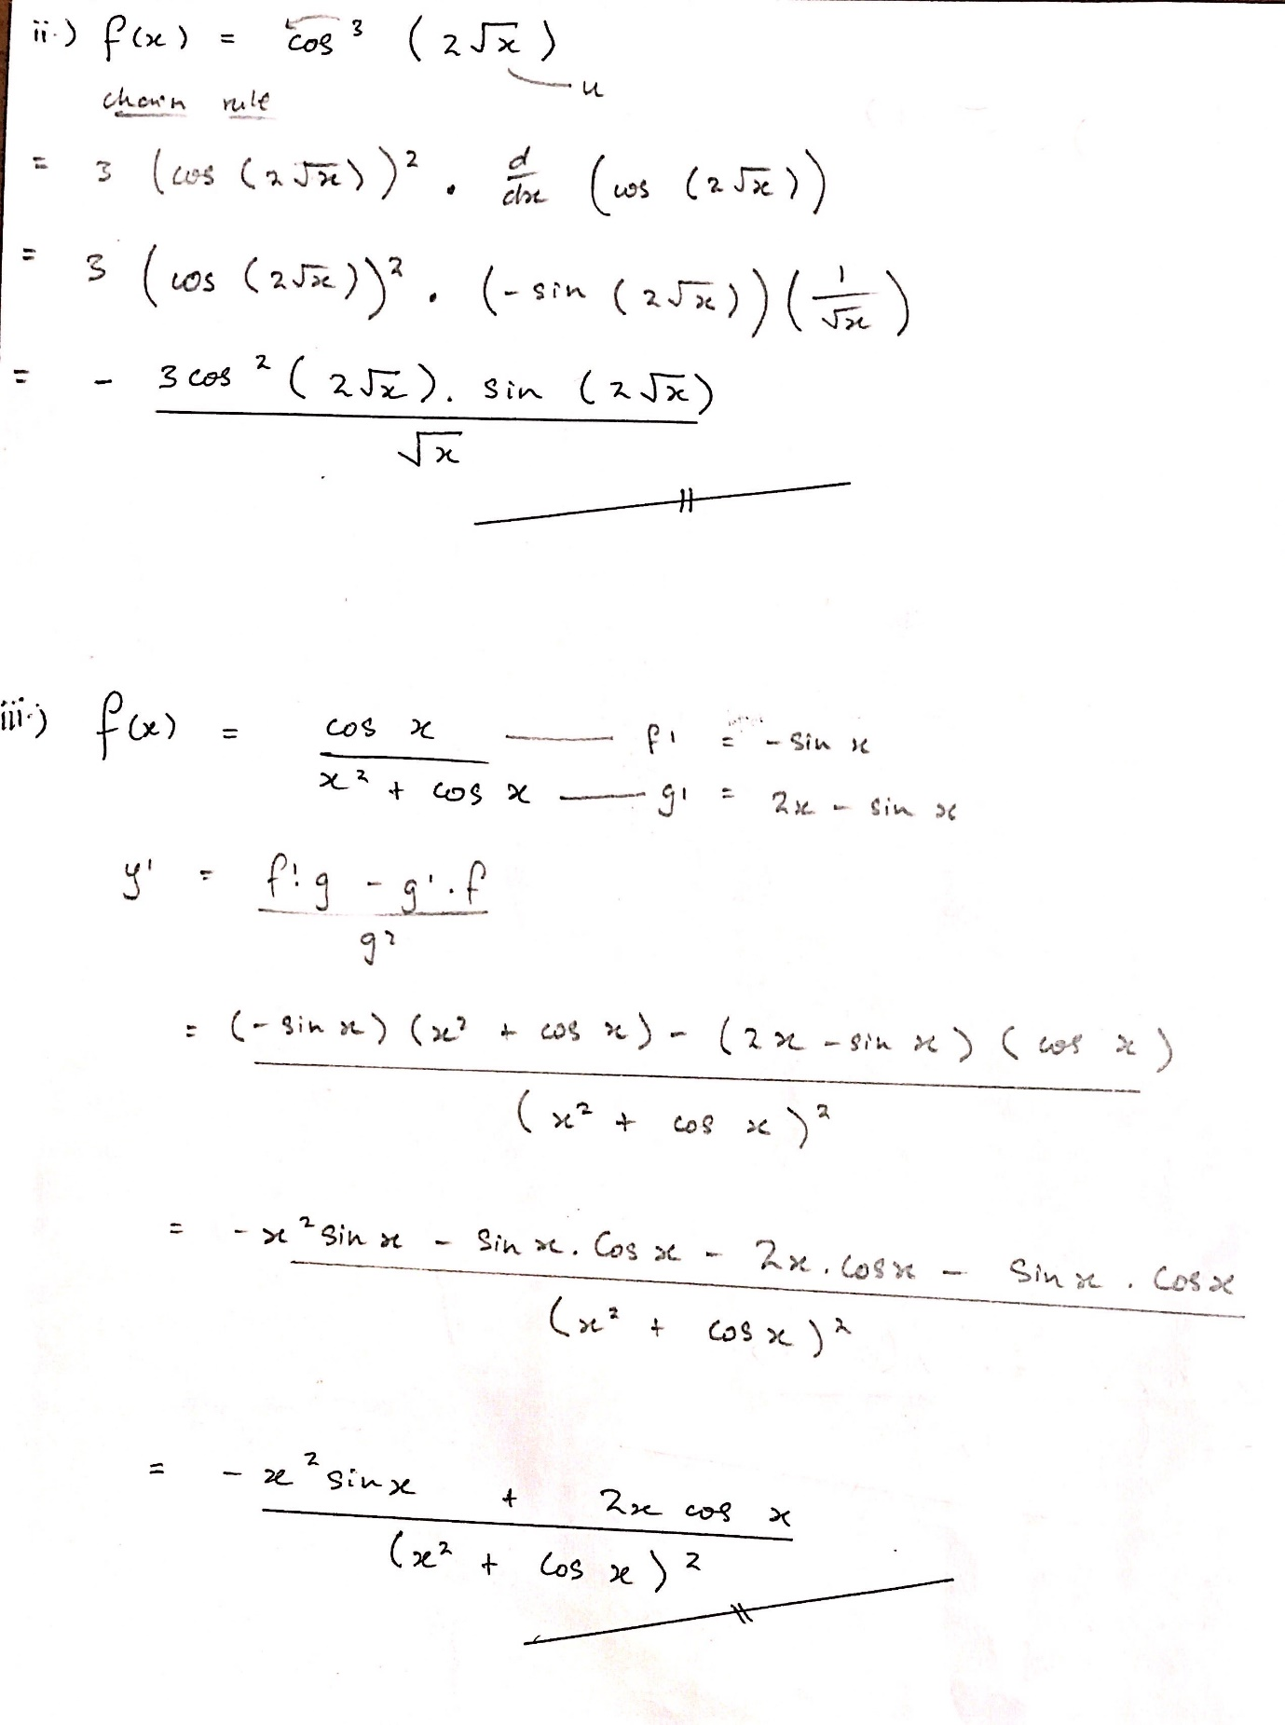

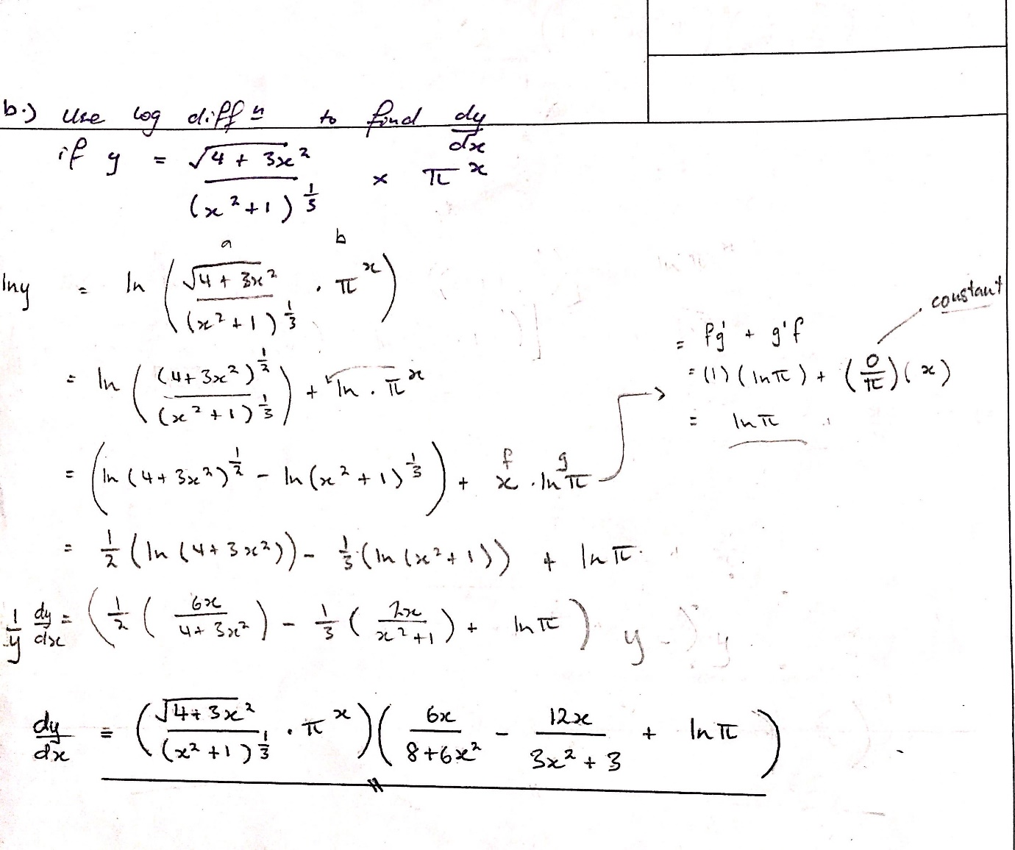

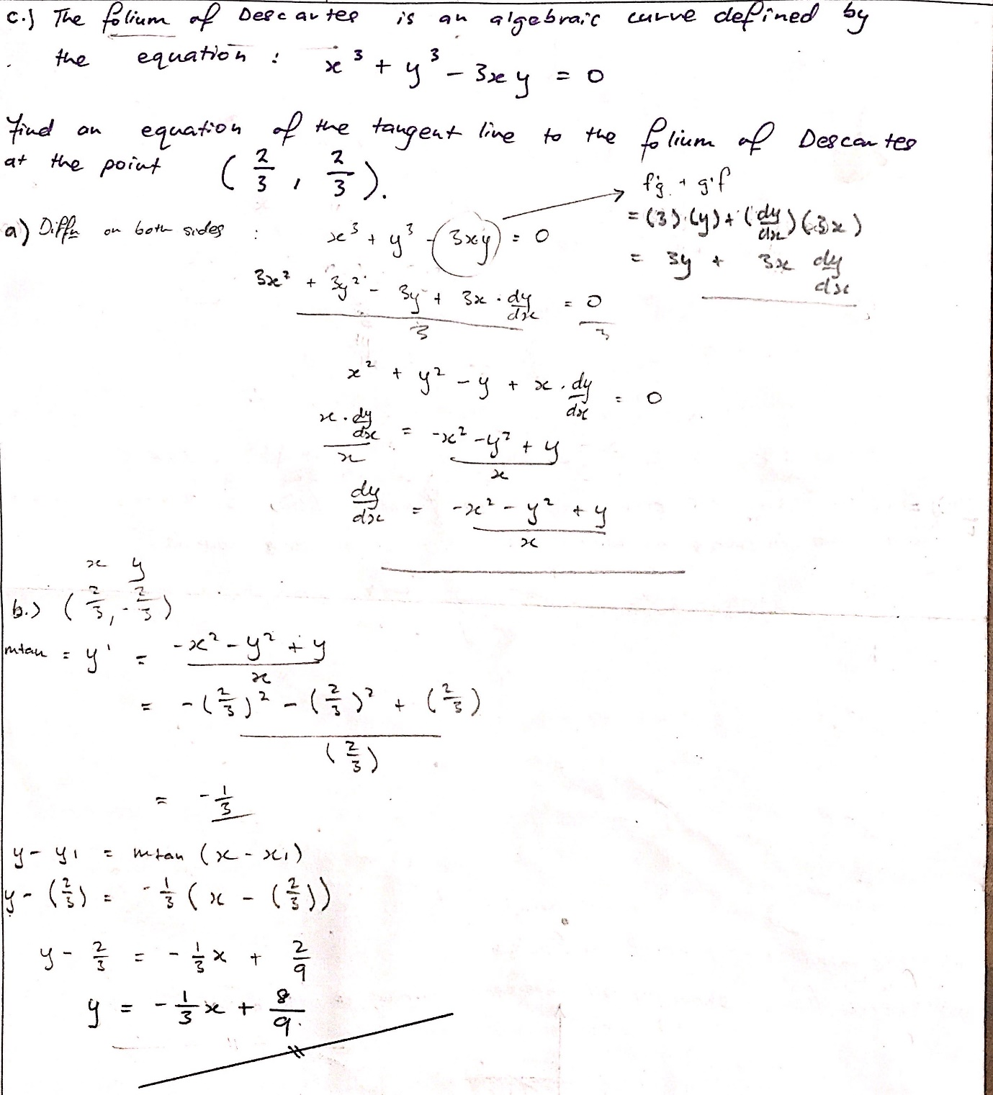

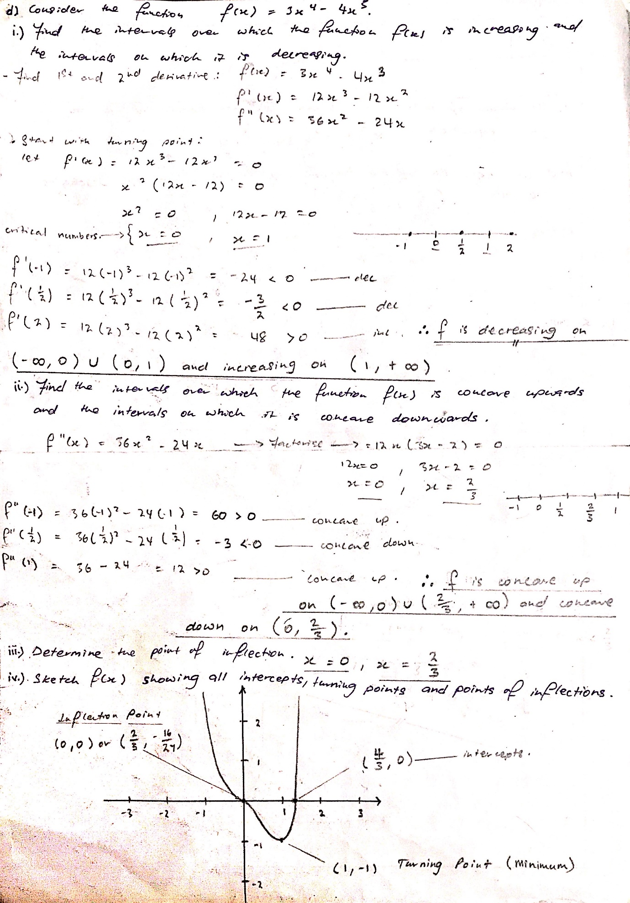

**Question.3**

a.)

To begin with, math assists me in many aspects of my daily life. Because math teaches me how to count and utilize arithmetic, I can tell the time when I wake up. Second, math has aided me in tracking calories while weighing my food, which has helped me become a better cook since I know exactly how much of each ingredient to use by weighing them. Third, when I go to the gym, math helps me figure out how much weight I'm lifting and how to improve my lifts. Knowing that I should be increasing my lifts by 2.5kg each week is simple when I know how to count. Fourth, with the help of mathematics (counting and arithmetic) I am able to know how much a full tank of gasoline would cost and how long it would last me. Furthermore, when I receive my allowance or any cash, I utilize mathematics to count the amount of money I have. This is really handy because my family has a business, and I occasionally fill in as the shopkeeper to relieve my mother of her duties. In addition, mathematics has increased my problem-solving abilities, which has helped me in other subjects I am taking, such as accounting, which involves a lot of money and counting. Moreover, mathematics has aided me in other areas, such as gaming. For example, in a shooting game, I would need to know how much ammo is left in my gun and whether or not I need to reload. Finally, mathematics aids me in planning my weekly sleep routine, such as how many hours of sleep I will require each day. I'd set my alarm according to how I'm feeling; if I'm exhausted, I'd set it for 8 hours; if I'm not, I'd set it at a time when I can get up early for my courses. To summarize, mathematics plays an important part in our lives, as seen by the examples given above. It has created a world where practically everything we do has something to do with mathematics, from simple counting to arithmetic to things as complex as imaginary numbers, thus it is critical that everyone attempt to comprehend and learn more about mathematics.

b.)

First let us make up a few assumptions and clarification

1. To clarify, t will be the number of days (x-axis) and y will be the number of population(y-axis)
2. We assume a person who is infected spreads the virus to an average of 2 people who aren’t infected, a day. It should look something like this tree diagram below.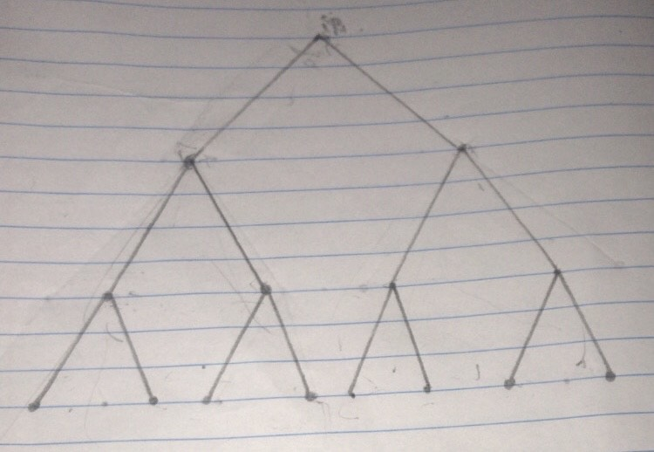

As we can see on day 1 there’s just one person infected and day 2 there’s 2 new infected. But the question asked for the total infected so total would be three people infected on day 2 and so on. This tree diagram shows a total of 15 people infected by day 4. In a set the number of newly infected would look like this: **{1,2,4,8….}** but we want the sum of all those numbers in the set so therefore we decided to use the sum formula for the geometric sequence which is: “**(a(1-r^n)/1-r**” where ‘**a**’ is the first term or first person in our case, ‘**r**’ is ratio or the rate the virus spreads each day which is 2 and ‘**n**’ is the term where all values before and including ‘**n**’ will be added or in our case ‘**n**’ would be ‘**t**’. Thus, our equation to calculate the total number of infected cases within the campus given the day is show below: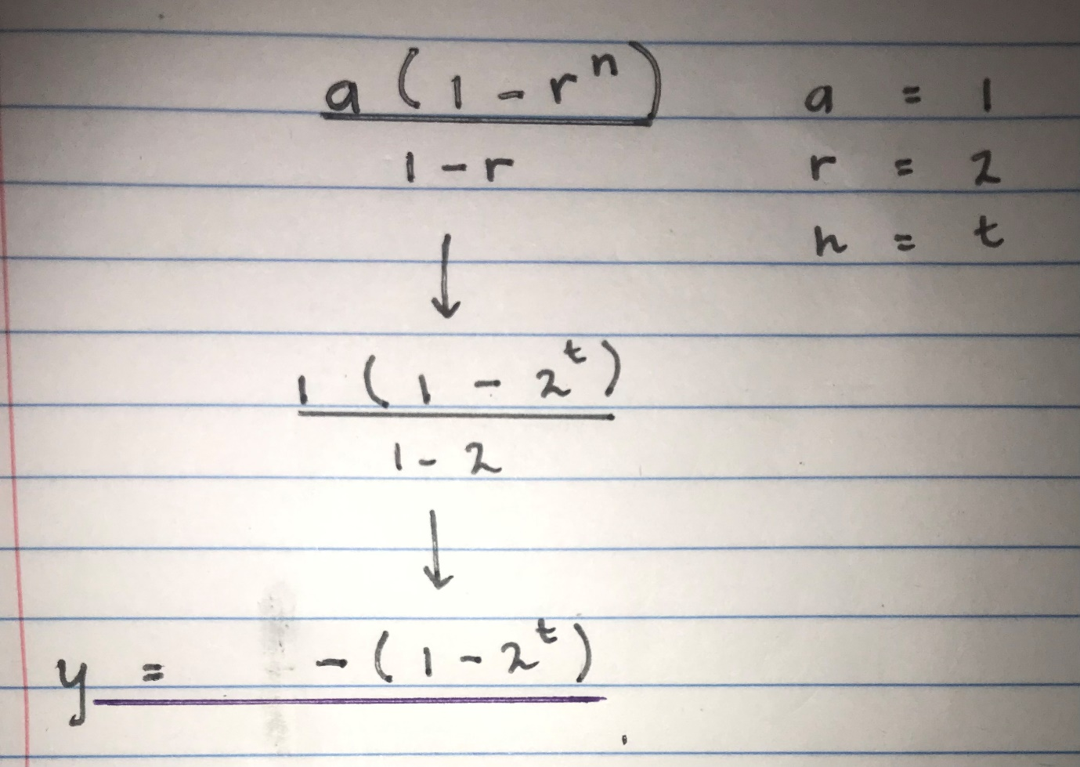

Further simplified will give us “**y = 2t-1**”.

1. Now let’s make the total population of the campus = **P** and let’s make **X** be the day that the whole campus is infected. Therefore **P=(2X)-1** and let’s make the **X** the subject of the formula. This will give us X=(Log[P+1])/Log2. Now if we know the population of the campus then we can find X. This is just so in case we do know the population of the campus, so then we’ll know the domain of the function. Thus, the domain of our function is “**1 =< t <=X**, t∈Z” and the range would be “**1 =< y <= P**, y∈Z”. We’ve made t and y element of integers because they can only be a whole number. Below is the graph of our function plotted on Mathematica where the population **(P) = 16383** thus making our **X = 14** so the domain of the graph is **“1 =< t <=14”** and the range is “**1 =< y <=16383**”.

